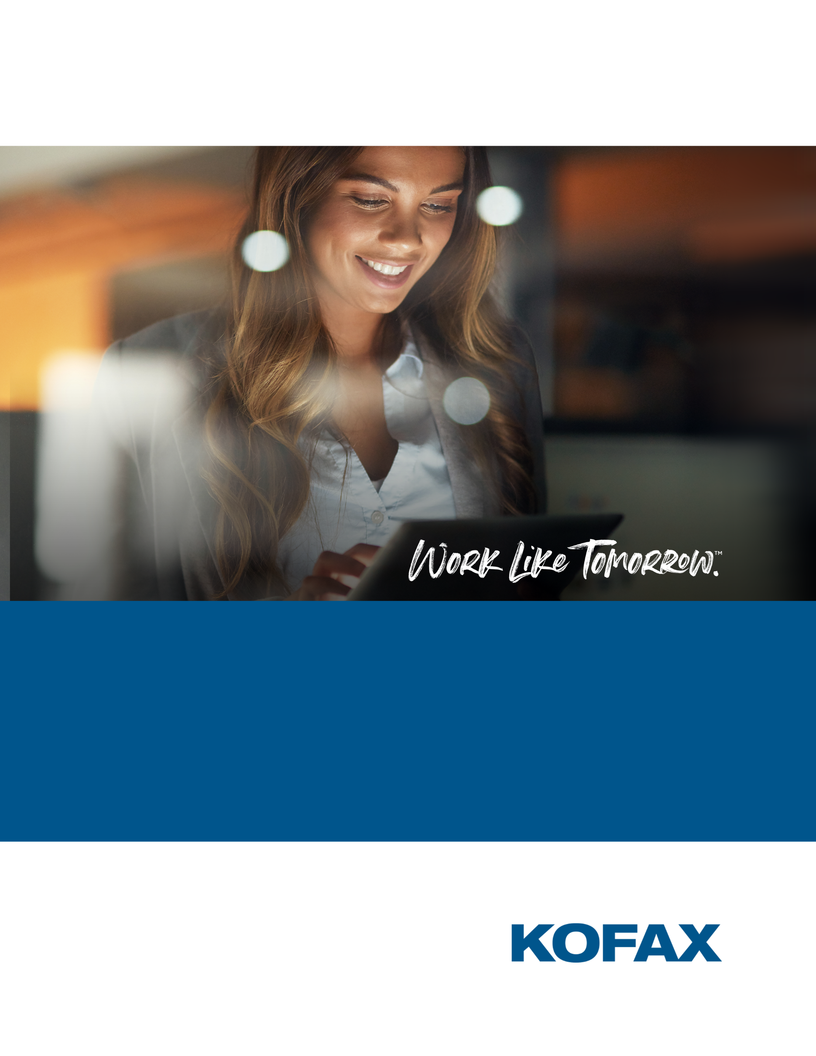

**Build your first Chatbot with Kofax RPA and Cognigy.AI**

July 2020  
Version 1.0

Contents

Contents

Contents 2

Introduction 3

What is Cognigy.AI? 4

What is Kofax RPA? 4

Prerequisites 4

A. Request a Cognigy Demo Account 4

B. Request Kofax RPA Demo License and Install Kofax RPA 4

C. Download and install the free version of NGrok 5

Install ngrok 5

Configure the Kofax Robot 7

Make the HardwareSearch Robot work faster for the chatbot 7

Upload the Robot to Management Console 9

Create Cognigy Project 10

Create a flow with a simple intent 11

Add Kofax RPA username and password 18

Connect to the Kofax Robot 19

Retrieve the price from the robot 26

Configure the Browser as the Endpoint 26

Test the Conversation 29

APPENDIX 1 30

How to Create a Custom Connector for Cognigy 30

Introduction

A step-by-step beginner’s guide to build the simple conversation below that uses Cognigy.AI to drive the conversation and a Kofax RPA robot to find information on a website. No knowledge of either Kofax RPA or Cognigy is assumed.

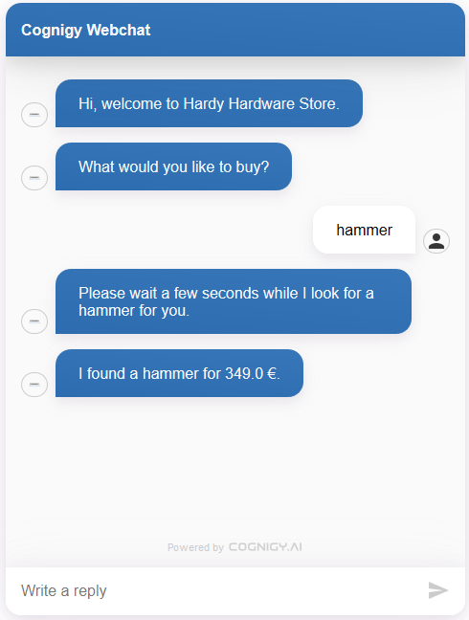

Use this tutorial to explore adding RPA to your conversational AI system, or to add conversation AI to your RPA solution.

This tutorial was built by  
**Derek Roberti**, VP of Technology at Cognigy  
**Alexander Teusz**, Consultant/Trainer at Cognigy  
**David Wright**, Partner Development Manager at Kofax

What is Cognigy.AI?

Cognigy.AI is a platform for automating conversations between people and systems.

Cognigy is a Kofax Technology Alliance Partner and is the only conversational platform that integrates with Kofax RPA, Kofax TotalAgility, Kofax Mobile Capture, and Kofax SignDoc out of the box.

What is Kofax RPA?

Kofax Robotic Process Automation is a zero-code, easy-to-use platform for building software robots which automate typical tasks on websites and desktop applications such as copying and pasting data between different business applications and manipulating pdf, Excel and other document formats.

Prerequisites

To complete the tutorial, you will need the following free items:

1. A free Cognigy demo account.
2. A free Kofax RPA trial license and download and install the software.
3. If you run Kofax RPA on a computer without a public IP address, you will need to set up the free version of Ngrok <https://ngrok.com/> (or equivalent) to allow Cognigy to communicate with your local RPA installation.

A. Request a Cognigy Demo Account

Visit <https://hubs.ly/H0rJlXG0> . When your request is processed, you will receive an automated email with account credentials and training materials.

Your Cognigy demo account runs on Cognigy's SaaS platform. This platform is provided at no cost for training purposes. In typical deployments, Cognigy may run on-premise, in a customer's cloud, in a managed hosting environment or in Cognigy's enterprise SaaS environment.

While this tutorial requires no prior knowledge of Cognigy, it will be helpful to complete the Getting Started tutorial (<https://docs.cognigy.com/docs/hello-world>) on the Cognigy Documentation site (<https://docs.cognigy.com/docs>). You may also review the additional training materials provided in your welcome email to familiarize yourself with Cognigy's user interfaces and overall product capabilities.

B. Request Kofax RPA Demo License and Install Kofax RPA

To request a demo license and installation for Kofax RPA, visit <https://www.kofax.com/Products/rpa/rpa-free-trial?crmCampaignID=CMP-14645-N3B9L9>

This tutorial assumes you have installed Kofax RPA on your own computer and that the **Design Studio** and **Management Console** are both running. Kofax RPA is very lightweight and can be installed even on smaller laptops.

C. Download and install the free version of NGrok

If you are installing Kofax RPA on your laptop or at your company, you will need to setup Ngrok to bypass your firewall safely using https.

Cognigy's demo system runs in a cloud environment but needs to be able to communicate with your installation of Kofax RPA.

If you have installed Kofax RPA with a cloud provider such as Microsoft Azure or AWS, you will already have a public IP address and can skip this step.

If you are running Kofax RPA on your local computer, for example, you will need to open a secure tunnel between your Kofax RPA installation and the internet. Using ngrok is a common and very simple approach to addressing this requirement. It is available in both free and enterprise versions. We only need the free version for this tutorial.

Install ngrok

1. Go to <https://ngrok.com> and create an account.
2. Download ngrok from <https://dashboard.ngrok.com/get-started> onto the machine that you installed Kofax RPA to. It must be the same machine.
3. Copy the authorization command from Step 3 into the clipboard **without the “./”** at the beginning. You will need it later. The token you see is your unique and secret personal token. You can also find the token at <https://dashboard.ngrok.com/auth>   
   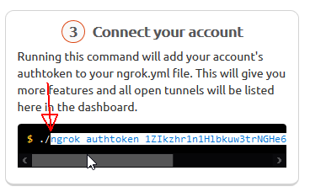
4. Open **Windows/Run** window, type **%userprofile%** and click **OK**. This will open your **User Directory**  
   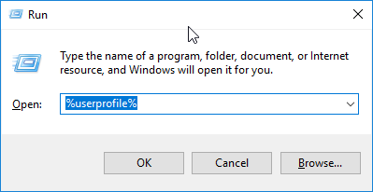
5. Open the downloaded zip file and drag **ngrok.exe** to your **User Directory**
6. Open **Windows/Run** window, type **cmd** and click **OK.**  
   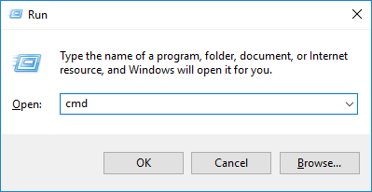
7. At the command line type the command you copied earlier from <https://dashboard.ngrok.com/auth> (without the “./” at the beginning) and press ENTER  
   **ngrok authtoken 1ZIkzh*****************************8**and press ENTER. This will authorize your computer with your account on the ngrok website. After 10-15 seconds and you will see the message **Authtoken saved to configuration file.**
8. Type **ngrok http 50080** at the command line and press ENTER. ***50080*** *is the**default**IP**port that Kofax RPA Management Console is listening on.*
9. You will now see the public internet address for your Kofax RPA Management Console on the line **Forwarding**. *Cognigy only connects to* ***https****. Kofax RPA uses* ***http*** *by default, but ngrok maps from one to the other which provides a secure connection between Cognigy.AI and Kofax RPA.*  
   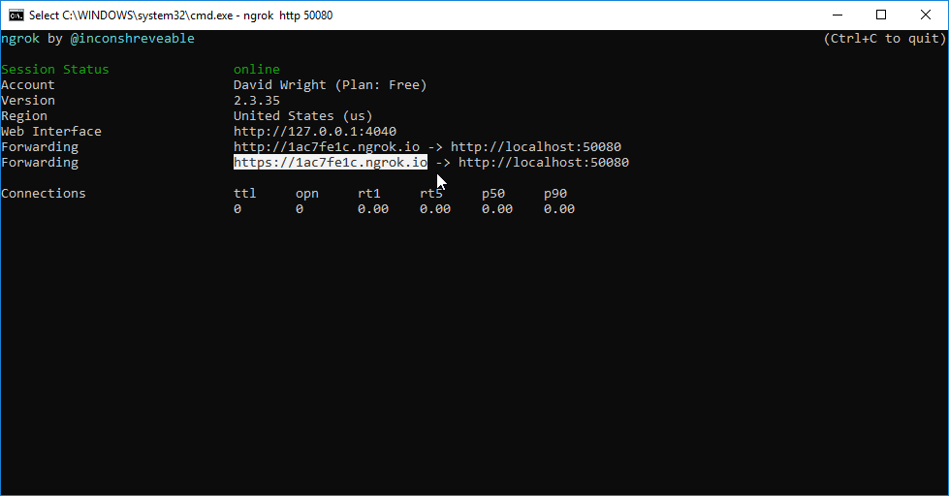

WARNING: Your machine is now open to the internet via this address, and by default your Kofax RPA Management Console has no security. It is possible that an attacker, who knew your ngrok address, could upload a robot to your machine and run it, though they would not have access to your file system as that is disabled by default. For this reason, you should close **ngrok** when not using it. You can see what is communicating with your machine by viewing the ngrok monitor [*http://127.0.0.1:4040*](http://127.0.0.1:4040) You can also add security and user management to your Kofax RPA Management Console to prevent any external access(See Admin Guide).

*Note: If you are using the free version of ngrok your public internet address will be different every time you run it,* and *you will need to update your Cognigy workflow to the new address.*

Configure the Kofax Robot

Make the HardwareSearch Robot work faster for the chatbot

This chatbot tutorial assumes that you have finished the RPA tutorial **“Learn How to Build Your First RPA Robot**” described in <https://www.kofax.com/Learn/Videos/kofax-rpa-tutorials>. This robot searches for an item on a Hardware Shop website and returns the price.

*(You can* download *the complete tutorial robot from* [*https://github.com/KofaxRPA/HowToBuildYourFirstRobot/releases/tag/1.00*](https://github.com/KofaxRPA/HowToBuildYourFirstRobot/releases/tag/1.00)*. Unzip the robot to your* ***My Robots*** *folder in* ***My Documents.****)*

You will need to make a few changes to the robot so that it works faster for the chatbot by Removing Excel from the robot and only letting it return 1 result.

*(You can* skip *this section by downloading the completed faster robot from* <https://github.com/KofaxRPA/HowToBuildYourFirstRobot/releases/tag/Cognigy_1.0> *Unzip the robot to your* ***My Robots*** *folder in* ***My Documents.****)*

1. Open the robot project in Design Studio  
   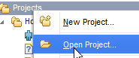
2. Open the robot **HardwareSearch.robot** and click **Prepare Execution**
3. Delete all the marked **steps** and **branches** in the robot since we do not need the Excel file. Delete the **Repeat** Step.  
   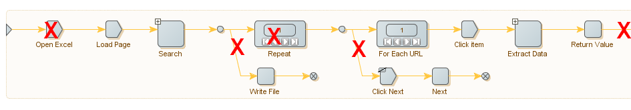
4. Your robot should now look like this  
   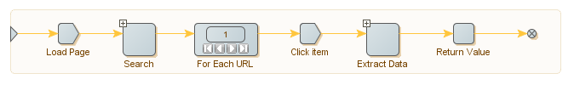
5. We do not want the robot to loop through all search results, but just return the first. Select the **For Each URL** step and change **Last URL Number** to **From First**. *This will now only process the first item.*  
   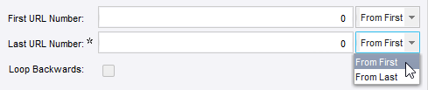
6. Click Debug and **Run** to test that the robot is working and only returning one result.  
   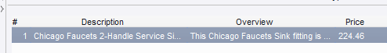

Upload the Robot to Management Console

1. Right-click on your robot and select **Upload**.  
   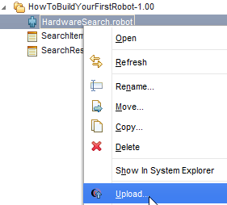
2. Select **Management Console (localhost), Default project** and **Remember this**  
   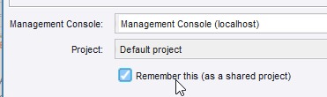
3. Leave the commit message, and click **OK**.  
   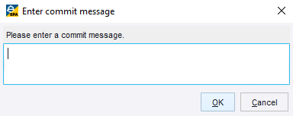
4. Open Management Console using the ngrok URL from Step 9 above. e.g. <http://1ac7elc.ngrok.io>. The Management Console can also be reached locally at <http://localhost:50080>.  
   *If it is not running, start it from the* ***WindowsMenu****/****KofaxRPA11/StartManagementConsole***
5. Select **Repository/Robots** and check that the **HardwareSearch** robot is there.  
   A screenshot of a social media post

   Description automatically generated

Create Cognigy Project

Now, you can build a natural language interface to call the robot.

1. Log into <https://demo.cognigy.ai/> with the credentials you received in your welcome email.
2. Read the license agreement for building conversational AIs.
3. Go to **My Profile** in the top right corner and select the **pencil** icon to change your password.
4. Create a new project by clicking the **+ button** at the bottom of the screen.

* [*https://docs.cognigy.com/docs/projects#section-creating-a-project*](https://docs.cognigy.com/docs/projects#section-creating-a-project)  
  

1. Name the robot "**Hardy Hardware Store**" or another name of your choice.  
   Select **Blank** as the Project template and click **CREATE** andthen **OPEN PROJECT.**   
   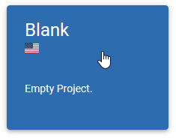

Create a flow with a simple intent

1. Click on the **New Item** "**+**" sign in the left bottom corner of the screen. Next, click on the top icon **Flow** (resembling a flow chart) to create a flow. Name your flow "Hardware Hardware Search". A close up of a logo

   Description automatically generated  
   After you create your flow, you will be taken to the Flow Editor.
2. Click on the **intents** icon in the task bar to open the Intent Editor.  
   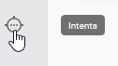
3. Click on the **+ button** in the bottom right corner and add a **Rule Intent**  
   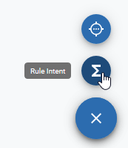
4. Name the intent **Greeting** and add the rule “ci.text===’GET_STARTED’”. This triggers the start of the conversation  
   A picture containing bird, flower

   Description automatically generated
5. **Save** the intent  
   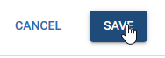
6. Go back to the Flow Editor  
   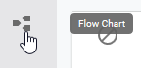
7. Click on the vertical ellipsis (3 dots) on the green START node and add a SWITCH node by selecting **Create Node** > **Logic** > **Switch**.   
   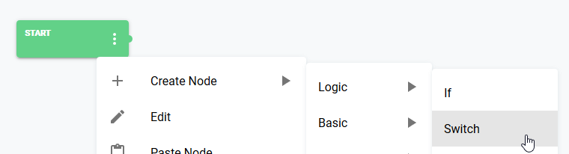  
   *Cognigy adds the SWITCH node along with two CASE nodes and one DEFAULT node.*  
   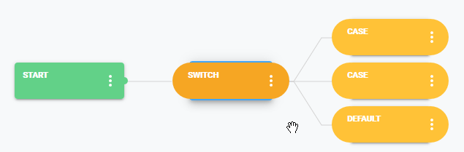
8. Double click on the SWITCH node to open it (or click on the vertical ellipsis and select Edit from the menu).  
   Change the **Type** to **Intent** and then click **SAVE NODE**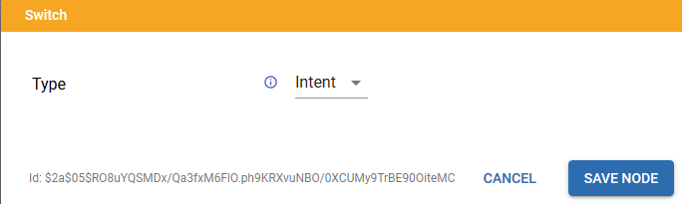  
   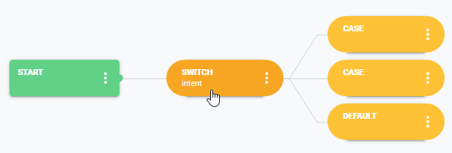
9. Double-click on the first CASE node and select the Greeting intent. Click SAVE NODE.  
   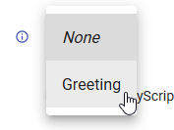 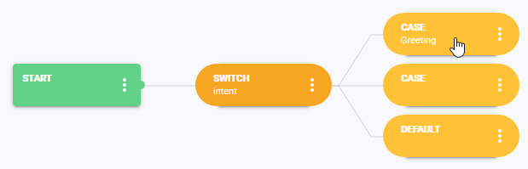
10. Delete the second CASE node by clicking on the vertical ellipsis and selecting **Delete Node**.  
    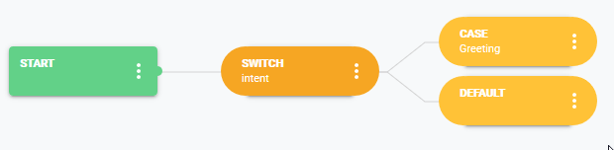
11. Add a **Basic/Say** Node to the CASE node called “Greeting”.  
    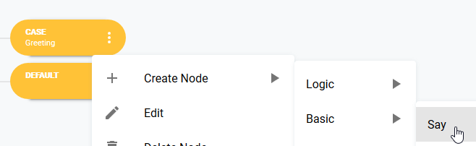  
    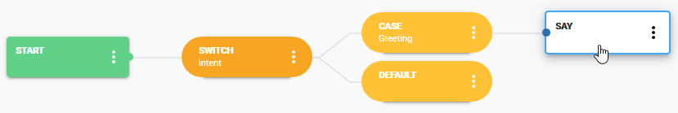
12. Double-Click the **SAY** node and add the text “Hi, welcome to Hardy Hardware Store.” And **Save** the Node.  
    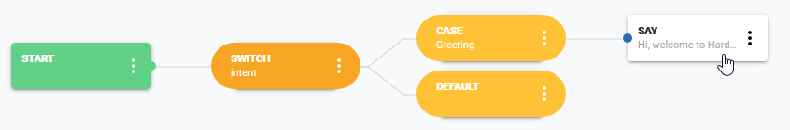
13. Add a second **SAY** Node and give it the text “What would you like to buy?”  
    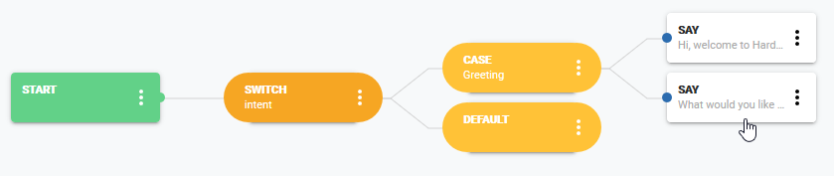
14. We want to take the answer to this question and add it to a token called Product. We will also add a token **Price** that we will get back from the Kofax Robot. **Click** on the **<** icon in the top-left corner and open the **TOKEN EDITOR** in the top-right corner.  
     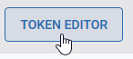
15. Click **+** button at bottom left corner and add a New Token with name **Product** and **Script** ci.text**.** *This simple chatbot* *will**take**everything the human types as the product name.***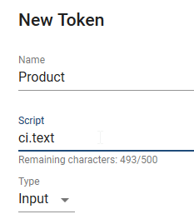
16. Add a second **token** with Name **Price**.Make sure the Type is **Context** and Script = **cc.hardwaresearchresult**.Click **Create.**  
    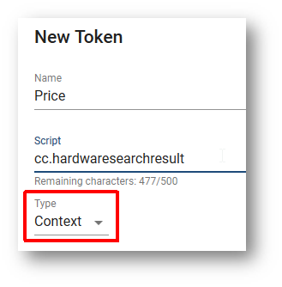
17. Your project now has two tokens. Click **<** to leave the **Token Editor.**  
    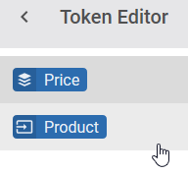 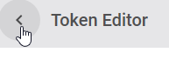

Add Kofax RPA username and password

Skip this section unless you have enabled user management in your Kofax RPA solution and added users and passwords.

This will allow Cognigy to log into your RPA Management Console to run the robot.

1. Click on **New Item** and add a new **Secret**  
   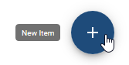 
2. Call it **Kofax RPA login** and click **Create**.  
   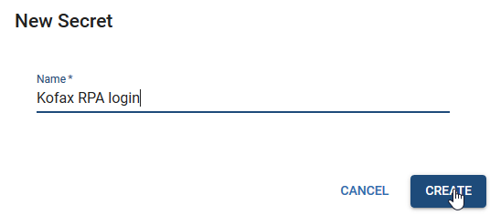
3. Add two **secret items** with keys **username** and **password** *(They must have exactly these names)*. Give them as values the credentials to login to Kofax RPA Management Console.  
   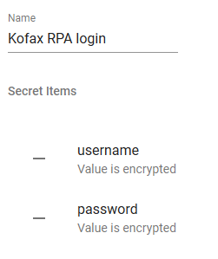

Connect to the Kofax Robot

1. Open the Flow Editor Again.   
   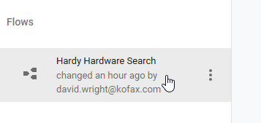
2. Add a new **Basic/Say** **Node** to the **Default** Node.  
   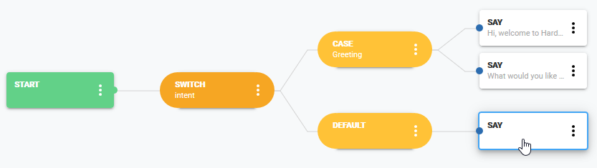
3. Double-click the **Say** node. Type **Please wait a few seconds while I look for a** into the Text fieldand then click the gray ball icon at the end of the field.  
   
4. Search for Product and Select the token you created.  
   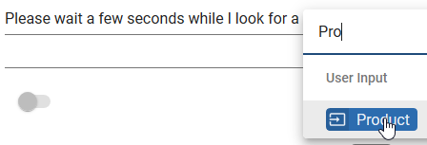
5. Complete the sentence with **for you.** And click **SAVE NODE**
6. Click on the **DEFAULT** Node and add **RPA Run Robot** Step under **CreateNode/Modules/Kofax/RPA Run Robot***This is a custom module created in collaboration between Kofax and Cognigy to integrate robots into a conversational AI. The source code of the custom module can be found here.*<https://github.com/Cognigy/CustomModules/tree/feature/kofax/modules/kofax>  
   *Do not select* ***RPA Run Robot Asynch***  *- that is for more advanced solutions where the conversation continues while the robot is running in the background. Our demo is very simple and will pause and wait for the robot to finish.*  
   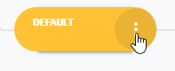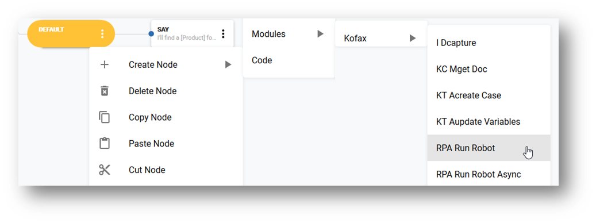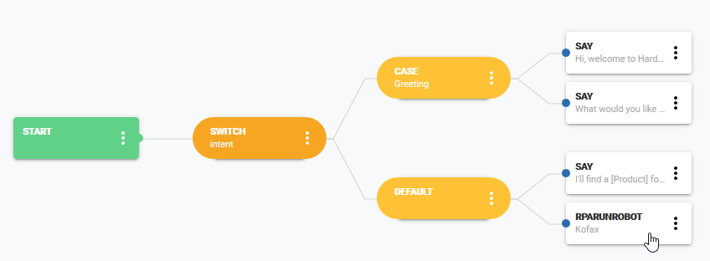
7. Double-Click the **RPARUNROBOT** Node. *Here you see all the parameters needed to talk to the robot. We will now look at the Robot Management Console to find all of these parameters.*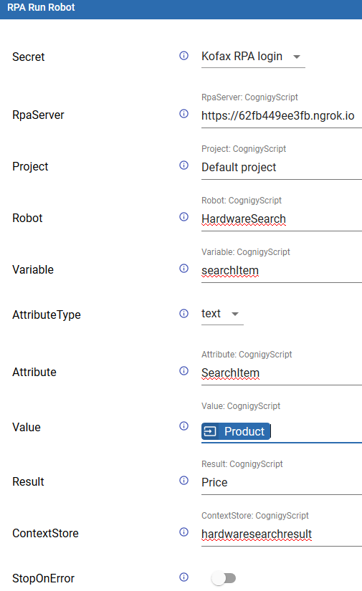
8. Open the https URL from ngrok in your browser. This will open your RPA Management Console.  
   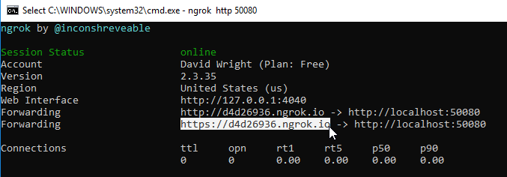
9. Go to **Repository/Robot** and make sure you have selected Project = **Default project.** Select the **HardwareSearch** robot and scroll far across to the right and click the **REST** icon  
     
   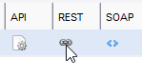
10. Select **JSON** for both Request and Response and press **Test Service**. This is exactly what the Cognigy Chatbot will do as well. You can read all the parameters from here – they are all case sensitive. *Note that “project” starts with a lower-case “p”, and “SearchItem” has a lower case “s” the first time and a capital “S” the second time.*

* **RpaServer=https://**********.ngrok.io:80** (*Make sure you have https and not http)* **Project=Default project  
  Robot=HardwareSearch  
  Variable=searchItem  
  AttributeType=text  
  Attribute=SearchItem  
  Value**= Select **Product** by clicking the grey ball icon at the end of the field.   
  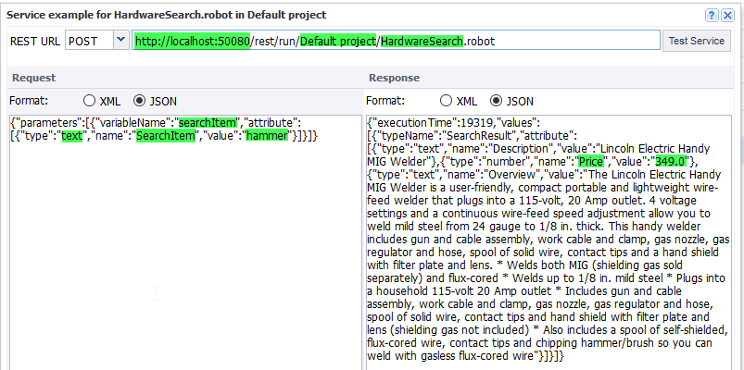

1. In Cognigy, set **Result** to be **Price**. *This simple demo will only return the price of* the *item. You can extend the demo if you like to show the image of the item and the description in the chat windows and provide a link to open the webpage.*
2. Set **ContextStore** to **hardwaresearchresult.** *This will store* the *price of the item into the conversation context.***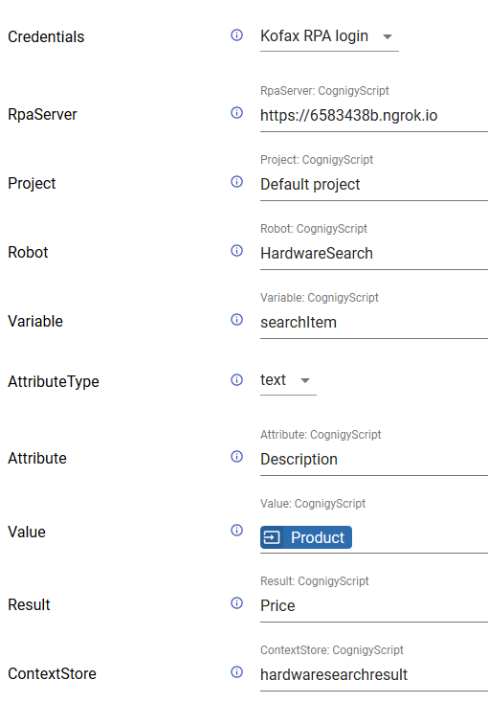**
3. Close the **RPA Run Robot** **configuration** window by clicking **Save Node.**

Retrieve the price from the robot

1. Add a new **Basic/Say** node after calling **the** robot.  
   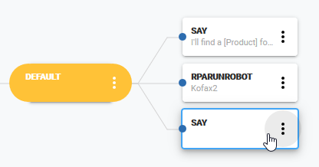
2. Add the sentence **I found a Product for Price €** to the **Text** **field** using the grey ball to insert **Product** and **Price.**  
   
3. Click **Save Node** and confirm that your flow looks like this.  
   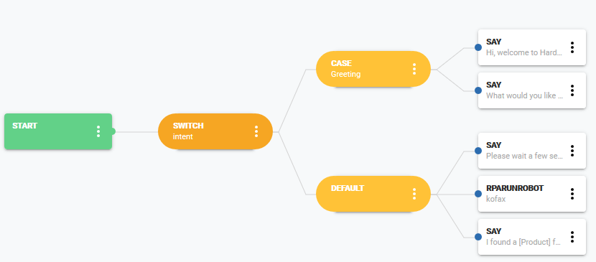

Your first conversation is now complete!

Configure the Browser as the Endpoint

The conversation needs an **Endpoint** to run in. An **Endpoint** could be Amazon Alexa, Facebook Messenger, Slack etc. But here we will just use a Browser.

1. Exit the Flow Editor by clicking **<** in the top **left** corner.  
   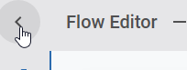
2. Click the blue **+** at the bottom and add a new **Endpoint**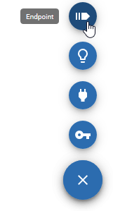
3. Name the Endpoint **WebChat Hardware Store** and make it of type **WebChat.** Click **Create.**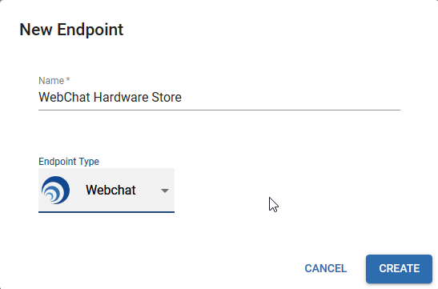
4. Select **Hardy Hardware Search** as **the** **Target Flow.**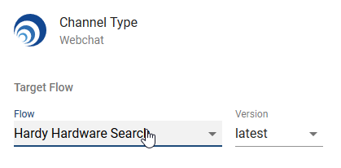
5. **Scroll down** to **Webchat Configuration** and set **Start Behavior** to “Auto **Send** a Message to the Bot”  
   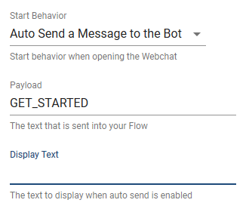
6. Make sure that the Payload is **GET_STARTED,** so that it **matches** the intent you created in step 29.
7. And the Display **text** is **empty**.
8. Click **OPEN WEBCHAT** in the top **right** corner.  
   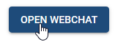

Test the Conversation

1. Enter 'hi' in the chat box and press ENTER  
   *The bot should respond by saying "What would you like to do?".*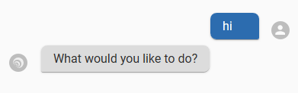
2. Now enter "hammer"  
   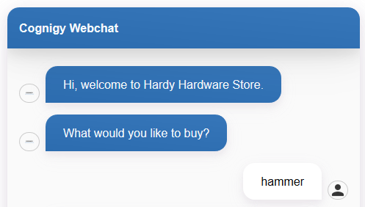
3. *After a few seconds the conversation will respond with the price of a hammer that it found.*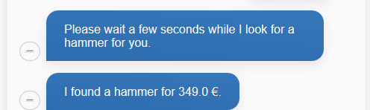

CONGRALUTIONS. You have just finished your first conversation AI that uses a robot.

APPENDIX 1

How to Create a Custom Connector for Cognigy

This appendix shows the steps that were followed to create the Kofax Connector for Cognigy.

You will need

* **node.js** from <https://nodejs.org/en/>
* **git** from <https://git-scm.com/downloads>
* **Visual Studio** or another code editor to edit the custom module
* **7zip** to zip the custom module together

Edit the custom module with the following command-line commands

**mkdir “Custom Modules”**

**npm install typescript**

**cd “Custom Modules”**

**git clone** [**git@github.com:Cognigy/CustomModules**](mailto:git@github.com:Cognigy/CustomModules)

**git checkout feature/Kofax**

**git fetch**

**cd modules\kofax\src**

**module.ts // to load it into Visual Studio for editing**

**npm ci**

**npm run build**

**"c:\Program Files\7-Zip\7z.exe" a Kofax_connector.zip build README.md package.json package-lock.json icon.png icon-large.png**

**"c:\Program Files\7-Zip\7z.exe" a kofax_connector_source.zip src\module.ts package.json package-lock.json**

Custom Module Uploading

Go to User Settings/Integration Framework.

Delete the old version if there before uploading the Connector **kofax.zip**.

 